ANA515 SU22 Assignment 1

Andrew Cutchin

2022-06-07

We have data about 100798 individuals killed by guns. Only 15687 are older than 65. The distribution of the remainder is shown below:

# Gun deaths by age

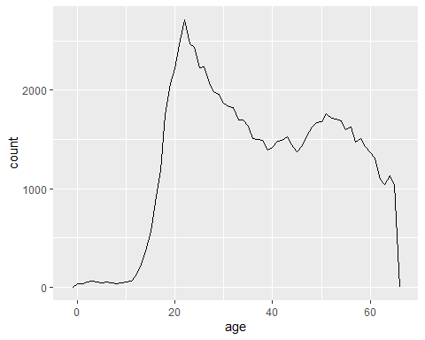

# Gun deaths by race

